

Composed
Hafiz Salman Majeed
www.vuaskari.com
Solved By”Mehreen”

CS101 Finalterm Long Questions Solved….
Question No: 31 (Marks: 1)
What is heuristic?
Heuristic is a procedure that usually, but not always, works or that gives nearly the right answer.
Question No: 32 (Marks: 1)
In programming, what is an object?

Object is a named collection of properties (data, state) & methods (instructions, behavior).

Question No: 33 (Marks: 2)
What is spreadsheet? List any two jobs that it can do.
A spreadsheet is a grid that organizes data into columns and rows. Spreadsheets make it easy to display information, and people can insert formulas to work with the data.

Electronic replacement for ledgers
Charts
Financial-forecasting.

Question No: 34 (Marks: 2)
In JavaScript, what is event handling? What are the two types of events?
In JavaScript capturing events and responding to them is event handling. The system
sends events to the program and the program responds to them as they arrive.
1. Events can include things a user does - like clicking the mouse.
2. Events that the system itself does - like updating the clock.

Question No: 35 ( Marks: 3 )
Explain how many ways businesses monitor their employees?

• Systems are available that monitor almost every key stroke that an employee makes on a computer.
• Systems are available that read and censor all incoming and outgoing eMail.
• It is quite straight forward to monitor where you surf the web.

Question No: 36 ( Marks: 3 )
What is difference between Design and System Architecture?

Note: Solve these papers by yourself
This VU Group is not responsible for any solved content


Composed
Hafiz Salman Majeed
www.vuaskari.com
Solved By”Mehreen”
System architecture is the conceptual design that defines the structure and/or behavior of a system. Whereas designs it as an independent, self-contained system.

Question No: 37 ( Marks: 3 )
What are the Sub categories of Artificial Intelligence? Briefly explain any two.

1. Expert systems:
Expert system is that system which is in some limited sense, can replace an expert.

2. Robotics:

Robotics is an automatic machine that performs various tasks that were previously done by humans.

Question No: 38 ( Marks: 5 )
How many ways are there to call a function in a program? Explain with example.
Two Ways of Calling Functions:

Functions do not run automatically. When the page loads, each function waits quietly until it is told to run.
1. A function calls appearing as a complete statement:

function popUp( message ) {
window.alert( message ) ;
}
popUp( “Warning!” ) ;

2. A function calls appearing as part of a statement. Definitions of such functions include a ‘return’ statement:
function add( a, b ) {
c = a + b ;
return c ;
}
sum = add( 2, 4 ) ;
document.write( sum ) ;

Question No: 39 ( Marks: 5 )

Note: Solve these papers by yourself
This VU Group is not responsible for any solved content

Composed
Hafiz Salman Majeed
www.vuaskari.com
Solved By”Mehreen”

Elaborate the ‘+ ’ operator and its constraints with the help of examples.
The + Operator Used on Strings. The + operator can also be used to add string variables
or text values together. To add two or more string variables together, use the + operator.

Example:
txt1="What a very";
txt2="nice day";
txt3=txt1+txt2;
Now txt3 will be having this value "What a very nice day". txt3=txt1+txt2; this statement due to + sign.
Question No: 40 ( Marks: 10 )
Write a JavaScript program having two functions sum and mean.
The web page will ask the user to enter five values to be added.
After taking input it will calculate the sum and mean of those values by calling sum and mean functions.

Question No: 41 ( Marks: 10 )
Define the following terms.

Object
Object is a named collection of properties (data, state) & methods (instructions,
behavior).
Event Handler
An event handler is a command which calls a function when an event happens, such as the user clicking a button.
Local Variable
Declaring variables (using the var keyword) within a function makes them local. They are available only within the function and hold no meaning outside of it.

Scope of Variable
Defining the space in which a variable is effective is known as defining the scope of a variable. A variable can be either local or global in scope.
Array
Array is an indexed list of elements.
Question No: 27 ( Marks: 1 )
What BIOS stands for?
BIOS stand for Basic input/output system.

Note: Solve these papers by yourself
This VU Group is not responsible for any solved content

Composed
Hafiz Salman Majeed
www.vuaskari.com
Solved By”Mehreen”

Question No: 28 ( Marks: 1 )
List down the Analytical Engine's components name (any two)
Input
Memory
Processor
Output.
Question No: 29 ( Marks: 2 )
Why uploading a web page is important? Describe in 2 - 3 lines.

By only uploading webpage we could place our information so that other can reach up to what we have loaded. Upload means make available our data or information for the world web browsers.

Question No: 30 ( Marks: 3 )
What is the difference between microprocessors and microcontrollers? Give one example of both.
The microprocessor is electronic equipment which can perform several functions and also processing of data and information present in a computer, while microcontroller can only perform one function for that its design.
Example:
Microprocessor: Pentium 4 & Personal Computer.
Microcontroller: Electrical device, washing machines, microwave ovens, telephones etc.
Question No: 31 ( Marks: 5 )
Differentiate uni-Processor OS from Multi-Processor OS.
Uni-processor OS’es is designed to schedule tasks on a single uP only whereas Multi-
processor OS’es can control computers having multiple uPs, at times 1000’s of them.
Question No: 32 (Marks: 5)
Why do we call JavaScript an Object-based Language?
JavaScript shares many similarities with object-oriented languages, and therefore is called an object-based language.
Question No: 31 (Marks: 1)
When does recursion occur?

Question No: 32 (Marks: 1)
What are the types of computer network according to the distance between nodes?
There are two types of networks.
1. LAN (Local Area Network)
Note: Solve these papers by yourself
This VU Group is not responsible for any solved content

Composed
Hafiz Salman Majeed
www.vuaskari.com
Solved By”Mehreen”

2. WAN (Wide Area Network)
Question No: 33 (Marks: 2)
What is meant by semantic error?
Occur when a statement executes and has an effect not intended by the programmer and Often times occur only in unusual & infrequent circumstances.
Question No: 34 (Marks: 2)
List down the names of two array methods available in JavaScript.
1. sort( ) [sorts elements in alphabetical order].
2. reverse( ) [Reverses the order of elements].
Question No: 35 ( Marks: 3 )
How can you define a consistent web design? Why is it needed?
A consistent good designed website is generated for general public that allows users to attain what they want as quickly as possible without spending much effort. A consistent good design is needed to assists the user in recovering from errors.
Question No: 36 ( Marks: 3 )
How can we include images in a web page using HTML and Java script? Image in HTML
<IMG src=URL, alt=text height=pixels width=pixels align="bottom|middle|top">
Image in Javascript
Images in JavaScript can be manipulated in many ways using the built-in object Image. Additional properties to HTML are hspace, vspace & lowsrc.
Example: It can be used by many handlers like, onAbort, onLoad & onError
Question No: 37 ( Marks: 3 )
The event handler attribute consists of three parts. Write about each of them.
1. The identifier of the event handler.
2. The equal sign.
3. A string consisting of JavaScript statements enclosed in double or single quotes.
Question No: 38 (Marks: 5 )
What is a packet in the network environment? What kind of information does it contain?
A packet is the smallest unit of data transmitted over a computer network. It’s a message to be transferred over the network is broken up into small packets by the sending computer.
Each packet contains the following info:
-Sender's address
-Destination address
-Data
-Error-recovery info.
Question No: 39 ( Marks: 5 )

Note: Solve these papers by yourself
This VU Group is not responsible for any solved content
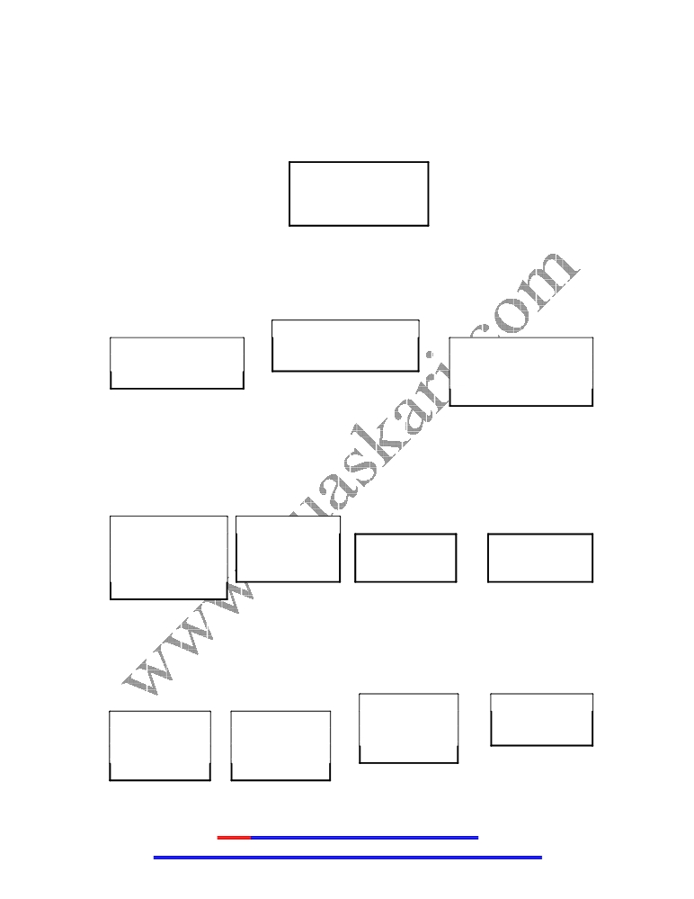

Composed
Hafiz Salman Majeed
www.vuaskari.com
Solved By”Mehreen”
Suppose we have a big project. Draw hierarchy of the people involved in the project?
Executive Team
CEO, COO,
CMSO

Architecture
Business Team Technology
Development Team Transfer
Team

Configuration Process
Management Team Team Quality Support
Assurance Team Team

Quality

Development Development
Development Development Team C Team D
Team A Team B

Note: Solve these papers by yourself
This VU Group is not responsible for any solved content


Composed
Hafiz Salman Majeed
www.vuaskari.com
Solved By”Mehreen”

Question No: 40 ( Marks: 10 )
Write down HTML and JavaScript code for the following requirements:
Declare an Array with the identifier SUBJECT having length 5. Assign following values to the array elements:
MIS, Java, Algorithms, Databases, C++
Show all values in reverse order.
Question No: 41 ( Marks: 10 )
How instant messaging works? Write the steps involved in this process.
The Instant Messaging services available allow us to maintain a list of people (contacts) that we interact with regularly. We can send instant messages to any of the contacts in our list as long as that contact is online.
Following steps are involved in IM working:
1. User commences the IM client.
2. IM client finds the IM server & logs in.
3. It launches communication info (IP address, etc) to the IM server.
4. IM server finds user’s contacts & sends him/her the communication info.
5. IM server also notifies the contacts that the user is online; sends his/her
communication info to them.
6. The user’s & the contact’s IM clients are ready to communicate directly (P2P).
7. As new contact has come online, IM server informs them about the user being
online & vice versa.
8. Multiple, real-time chat are possible.
9. When the user logs-off, his/her IM client informs the IM server.
10. IM server wipes away the temporary file and informs the user’s contact’s about his/her ‘offline’ status.
Question No: 5 ( Marks: 10 )
What kind of operations takes place inside Microprocessors Building Blocks? Enlist them with brief description.

Bus Interface Unit: The bus interface unit is the part of the processor that interfaces with the rest of the PC. Its name comes from the fact that it deals with moving information over the processor data bus.

Instruction Decoder: The instruction decoder of a processor is a combinatorial circuit sometimes in the form of a read-only memory, sometimes in the form of an ordinary combinatorial circuit.

Note: Solve these papers by yourself
This VU Group is not responsible for any solved content

Composed
Hafiz Salman Majeed
www.vuaskari.com
Solved By”Mehreen”

Arithmetic & Logic Unit (ALU): An arithmetic and logical unit (ALU) also known as “Integer Unit” is one of the core components of all central processing units. It is capable of calculating the results of a wide variety of common computations.

Floating-Point Unit (FPU): A floating point unit (FPU) is a part of a CPU specially designed to carry out operations on floating point numbers.
Registers: A register is a device for storing data. It is a small amount of very fast computer memory used to speed the execution of computer programs by providing quick access to commonly used values.
Control Unit: A control unit is the part of a CPU or other device that directs its operation. The outputs of the unit control the activity of the rest of the device.

Instruction Set: This is the set of machine instructions that a microprocessor recognizes and can execute. It is the only language microprocessor knows.
Question No: 7 ( Marks: 8 )
a) Differentiate between SMTP and POP3 server. (3 marks)

SMTP (Simple Mail Transfer Protocol) is a protocol used to send and receive eMail messages over a TCP/IP network. Whereas POP3 (Post Office Protocol) is a protocol used for receiving eMail messages. A POP3 server maintains text files (one file per user accounts) containing all messages received by a user. eMail client interacts with the POP3 server for discovering and downloading new eMail messages.

b) How can you justify that a DBMS is better to use than Flat-file database? (5 marks)

A DBMS takes care of the storage, retrieval, and management of large data sets on a
Database. It provides SW tools needed to organize & manipulate that data in a flexible
manner.

Whereas in Flat-file database the text file format makes it hard to search for specific information or to create reports that include only certain fields from each record.
Question No: 8 ( Marks: 8 )
What will be the output of this programme? Write comments where you find “//” symbol in the following code.
<html>

Note: Solve these papers by yourself
This VU Group is not responsible for any solved content

Composed
Hafiz Salman Majeed
www.vuaskari.com
Solved By”Mehreen”

<head>
<script language="JavaScript">
function doSomething() { // 1
setTimeout('doSomething()',10000); // 2
}
</script>
</head>
<body onLoad="doSomething()"> // 3
document.write(“Virtual University of Pakistan”); </body>
</html>
// 3 document.write(“Virtual University of Pakistan”);
Question No: 9 ( Marks: 8 )
a) How Trojan Horses and Worms affect a computer system? What guidelines
should be adopted to troubleshoot with malicious software? (6 marks)
Trojan horses are stand-alone programs. The look like what they are not and appear to be something interesting and harmless (e.g. a game) there execution results in destruction. Worms only make copies of themselves on the infected computer.

Following guidelines should be adopted to troubleshoot with malicious software:
• Download SW from trusted sites only.
• Do not open attachments of unsolicited eMails.
• Use floppy disks and CDROMs that have been used in trusted computers only.
• When transferring files from your computer to another, use the write-protection notches.
• Stay away from pirated SW.
• Regularly back your data up.
• Install Antivirus SW; keep it and its virus definitions updated.
b) Which part of a virus consists of malicious computer instructions? (2 marks)
Payload is the part of virus that generally consists of malicious computer instructions.

Question No: 31 ( Marks: 1 )
What is the function of Network Interface Card?
NIC is an I/O device that plugs into the computer and it enables it to communicate over a network.

Question No: 32 (Marks: 1)
In programming, what is a loop?

Note: Solve these papers by yourself
This VU Group is not responsible for any solved content


Composed
Hafiz Salman Majeed
www.vuaskari.com
Solved By”Mehreen”
A loop is a programming language statement which allows code to be repeatedly executed.
Question No: 33 (Marks: 2)
What is an intelligent system?

Intelligent system is a SW programs or SW/HW systems designed to perform complex tasks employing strategies that mimic some aspect of human thought.
Question No: 34 (Marks: 2 )
Why hub is used in networks?

Hub is networking equipment and a device which connects several computers to form a network. In a network the NIC translates the message into electrical pulses suitable for the computer network in use & transmits it to the hub through the cable. The hub receives them and forwards them to all computers connected to it.

Question No: 35 ( Marks: 3 )
What are Trojan Horses?

Trojan Horses are unlike viruses, they are stand-alone programs. The look like what they are not. They appear to be something interesting and harmless (e.g. a game) but when their execution result in destruction.
Question No: 36 (Marks: 3)
Elaborate with examples Vector or Object oriented graphics.

Vector or Object-Oriented Graphics treats everything that is drawn as an object. Objects retain their identity after they are drawn. These objects can later be easily moved, stretched, duplicated, deleted, etc
They are resolution independent and relatively small file size. Examples: swf, svg, wmf, ps.
Question No: 37 (Marks: 3)
How can you define a consistent web design? Why is it needed?
A consistent web design should be the one that achieves the result that it was designed for, that result can only be achieved by giving the user what he wants, as quickly as possible, without her/him expending much effort. One definition of usability: Let the user have what he wants, quickly, without much effort “Quickly” is important!

Question No: 39 (Marks: 5)
What are the advantages of multimedia presentations? Write any five.
Following are the advantages of multimedia presentations:

Note: Solve these papers by yourself
This VU Group is not responsible for any solved content

Composed
Hafiz Salman Majeed
www.vuaskari.com
Solved By”Mehreen”

· Great tool for effectively communicating ideas to an audience
· All electronic
· Easy to make last minute changes
· The undo feature encourages experimentation
· More attractive; commanded more interest
· May include animations, sound, video
· Easy to catalog, store, and recall
· Great tool for making presenter-free interactive material (e.g. self-learning tutorials)

Question No: 41 (Marks: 10)
How virtual communities are formed? How these are different from other communities? Give examples.
Virtual Communities are interest-based communities. Members with common interest
share ideas, ask questions, post answers and make announcements through mailing-lists,
news groups or message boards. This is how they are formed. These communities are
definitely very different from traditional ones. There are generally no bars on
membership based on gender, race or religion. However, they may lack the respect for
the individual and civility that are the norm within conventional, geography-based
communities.

Note: Solve these papers by yourself
This VU Group is not responsible for any solved content

